**MODULE-1 (FUNDAMENTAL)**

1. What is SDLC?

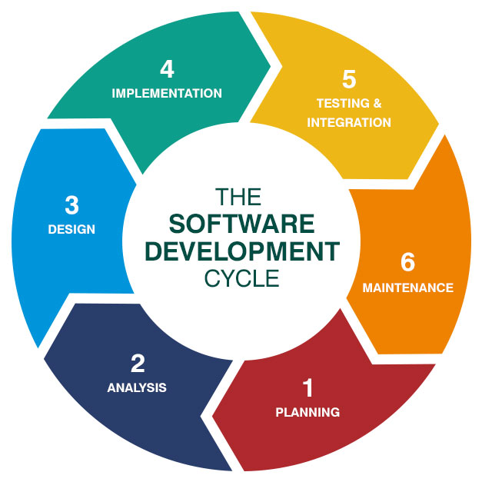

* The software development life cycle is used to design and build high quality software. It is used for minimize project risks through forward planning so that software meets customer expectations during process and when it is completed. It is a process for planning, creating, testing and implementing information system. This methodology provides a systematic management framework with specific deliverables at every stage of software development process. There are six phases of SDLC name as Requirements gathering, Analysis, Design, Implementation, Testing, Maintenance.

1. What is software testing?

* Software testing is a process of finding errors in a developed product and checking the quality of software before launching to ensure that all requirements are fulfilled.

1. What is agile methodology?

* The agile methodology is a project management approach that involves breaking the project into phases and work continuously and improvement. Each phase functions working simultaneously on various areas like planning, requirements, analysis, design, coding and testing.

1. What is SRS?

* The software requirements specifications describes a detailed description of all requirements in software system to be developed that customer wants. It is an agreement between customer and contractors. There are three important parts of SRS documents are functional and non-functional requirements of the system and goals of implementation. The key components of SRS are description of document’s purpose, way of business idea implementation, scope of work, overview of future product, general description of project, user characteristics, benefits, features, functions.

1. What is OOP?

* Object oriented programming is based on concept of objects which can contain data and functions. Programs are divided into objects and it is communicate with other objects through functions. The use of OOP in a code is to increase the reusability and maintainability of code which can make it easier to upgrade and update the system.

1. Write basic concepts of oops

* Class
* Objects
* Data Abstraction and Encapsulation
* Polymorphism
* Inheritance
* Dynamic binding

1. What is object?

* It is an instance of a class. It contains real values instead of variables.

1. What is class?

* A class is template definition of methods and variables bundled together under a unit. Class is a collection of similar objects.

1. What is encapsulation?

* Data encapsulation is used to bundle the data and methods into a units.

1. What is inheritance?

* The capability of a class to derive properties & characteristics from another class is called inheritance. It is a programming procedure that allows you to reuse code by referencing the behaviors and data of object. It is very important feature of OOP.

1. What is polymorphism?

* It means having many forms. It allows a specific routine to use variables of different types at different times.

1. Draw use case on online book shopping 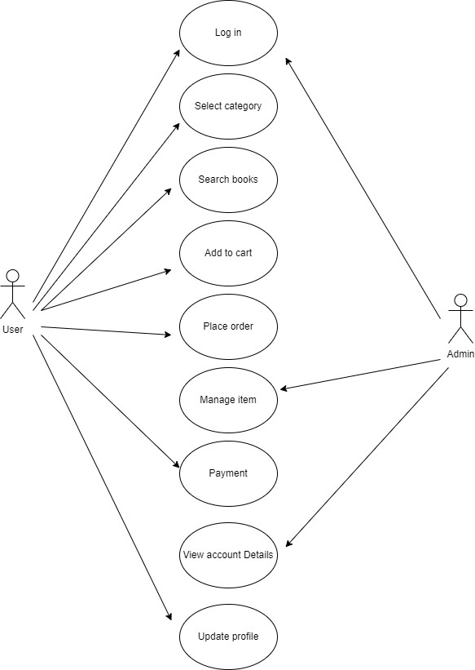
2. Draw use case on online bill payment system(paytm)

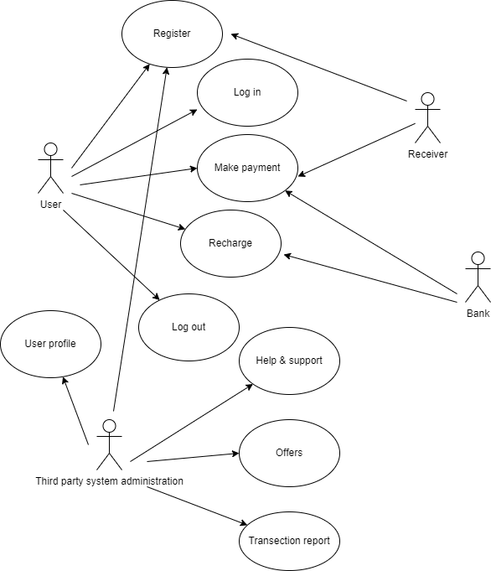

1. Write SDLC phases with basic introduction?

* Requirements gathering:- Requirement gathering is an act of generating a list of requirements to define about project and its goal. If requirements are not gathered properly it may lead to incorrect or incomplete understanding of problem that is why this phase is most important phase. There are two types of requirements that is functional and non-functional requirements.
* Analysis:- This phase defines the detailed functional user requirements using high level requirements identified in the initial phase. The requirements are defined in this phase to a level of detail sufficient for systems design to procced. It describes clear description of all requirements. This phase helps to understand business needs and what to do to fulfil that.
* Design:- There is two types of designs like HIGH LEVEL DESIGN and LOW LEVEL DESIGN. The HLD refers the architecture of overall system, whereas LLD refers the internal design of the system.
* Implementation:- In this phase, the team will create software and write the code and create the necessary files to complete the project. The team will also create a testing plan to ensure that the software is bug free.
* Testing:- The testing phase is used to verify the functionality of the system and ensure that it meets the specified requirements. During this phase the team will test the software to ensure that it meets the user requirements and bug free. The team will find a bug or defect then track it and fix it according to requirements. This phase is important to ensure that the software is properly tested and the project is completed on time and within budget.
* Maintenance:- when the system is tested and verified it is ready for maintenance phase. During this phase the team will monitor the software and make any necessary changes or updates to ensure that it continues to meet the user requirements. This phase is important to ensure that software is properly maintained and project is successful.

1. Explain phases of waterfall model

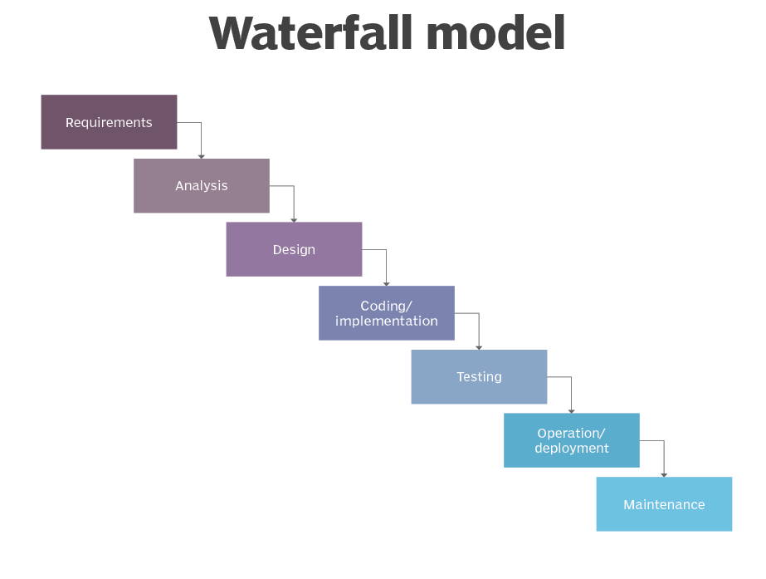

* Requirements:- The phase involves gathering requirements from stakeholders and analyzing them to understand the scope and objectives of the project.
* Design:- Once the requirements are understood, the design phase begins. This involves creating a detailed design document that outlines the software architecture, user interface and system components.
* Implementation:- This phase involves coding the software based on the design specifications. This phase also includes unit testing to ensure that each component of the software is working as expected.
* Testing:- In this phase, the software is tested as a whole to ensure that it meets all requirements and is free from defects.
* Deployment:- Once the software has been tested and approved, it it deploy to the production environment.
* Maintenance:- This final phase involves any issues that arise after the software has been deployed and ensuring that it continues to meet the requirements over time.

1. Write phases of spiral model

* The spiral model has four phases:- Planning, Risk analysis, Product development, Next phase planning and evaluation

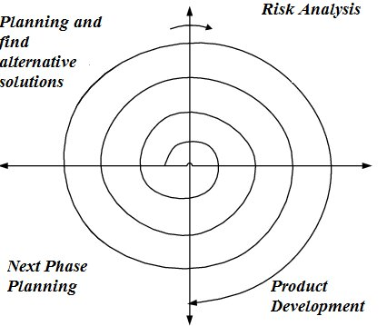

* Planning:- In this phase, the scope of project is determined and a plan is created for the next iteration of spiral.
* Risk analysis:- In this phase, the risks associated with the project are identified and evaluated.
* Product development:- The software is developed based on the requirements gathered in the previous iteration. The software is evaluated to determine if it meets the customer’s requirements and if it is of high quality.
* Next phase planning:- The next iteration of spiral begins with a new planning phase, based on the result of the evaluation. The spiral model is used for the complex and large software development project.

1. Write agile manifesto principles

* Individuals and Interactions
* Development of working software takes precedence over detailed documentation and paperwork
* Customer collaboration
* Responding to change

1. Explain working methodology of agile model and also write pros and cons

* Agile model believes that every project needs to be handled differently. It is most commonly used model in software development and stated becoming popular with time due to its flexibility and adaptability.
* The agile methodology is a project management approach that involves breaking the project into phases and emphasizes continuous collaboration and improvement.
* **Pros:-**
* Functionality can be developed rapidly and demonstrated.
* Suitable for fixed or changing requirements
* Delivers early partial working solutions.
* Minimal rules, documentation easily employed.
* Little or no planning required.
* Easy to manage.
* Promotes team work and cross training.
* Resource requirements are minimum.
* Error can be fixed in the middle of the project.
* **Cons:-**
* Not suitable for handling complex dependencies.
* Depends on customer interaction so if customer is not clear team can be driven in wrong direction.
* Transfer of technical to new team members may be quite challenging due to lack of documentation.

1. Draw use case on online shopping product using COD

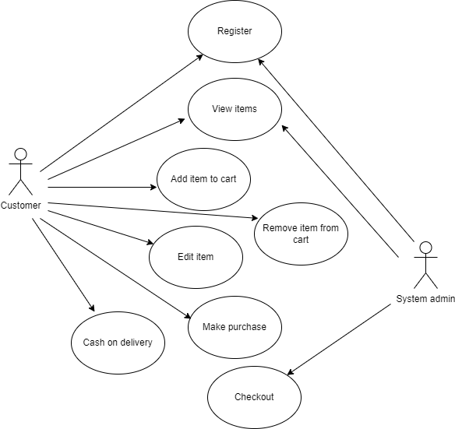

1. Draw use case on online shopping product using payment gateway

